LECTURE 1 – TOOLS FOR THINKING ABOUT DESIGN (ALBERTO CAIRO)

In his book, the Functional Art, Alberto Cairo provides a tool for thinking about design tradeoffs when building information graphics, and he calls this tool the Visualization Wheel.

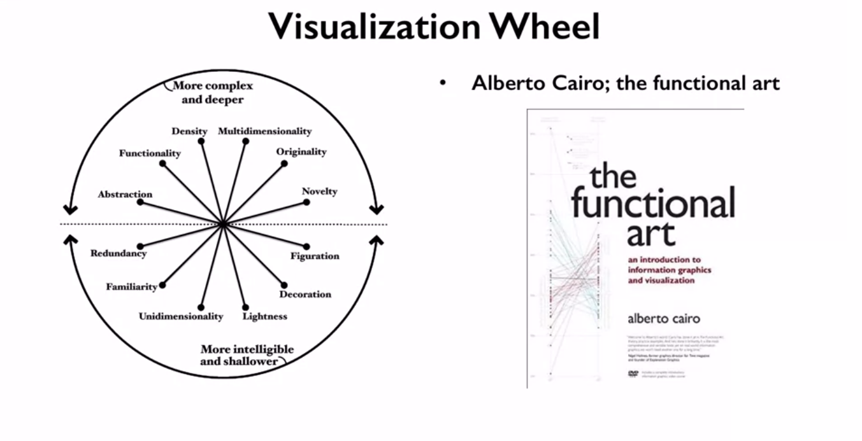
In this conceptualization there are two poles of a circle. The top one represents highly complex data which informs at a deep level. While the bottom provides easier access to data but only informs in a shallow manner. Inside the circle are dimensions which describe tradeoffs between two approaches. While Cairo provides a number of interesting dimensions. It's important to note that this is a tool for designers to think about their visualizations. And not so much an analytics tool itself. Your needs from any particular problem might change which of these dimensions are important or might introduce new dimensions which you should be thinking about. Cairo actually suggests a role in an organization or a professional background might also influence the kinds of graphics we want to make. So I'd like to ask you as someone who's studying data science, who are you trying to reach through your visualizations?

Let's dig in and look at a few of the trade offs that Cairo considers.
The first is abstraction and figuration. A highly figurative visual describes the phenomenon using physical representations of the phenomena, such as photographs or drawings. As the representations become less real and more conceptual, the emphasis shifts from figuration to abstraction.
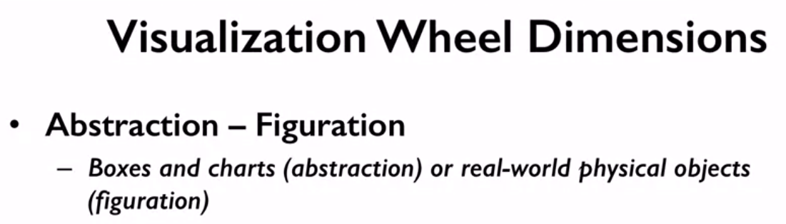

The second dimension he discusses is, is functionality and decoration. A completely functional graphic has no embellishments and is closer to a direct representation of the data. While a heavily decorated graphic has more artistic embellishments.

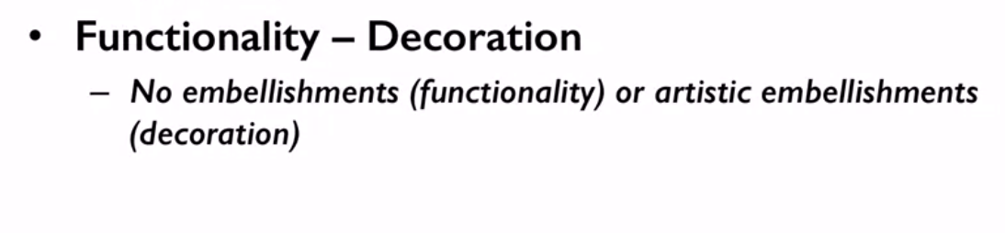

As it is with all of these dimensions, there isn't a clear better or worse. Embellishments may increase the amount of time a viewer spends considering the visual. Exploring it's nuances and
forming mental associations which may increase familiarity and memorability.

The third dimension is density and lightness as they relate to the amount of information being shown. There are lots of great examples of this in scientific visuals, where some figures are intended to be studied in depth, while others are meant to quickly augment a narrative. You can see this dimension at play when comparing magazine infographics, where the reader is likely to be more heavily engaged in the content. Two advertisements in the same magazine where readers are likely to only quickly consider an ad.

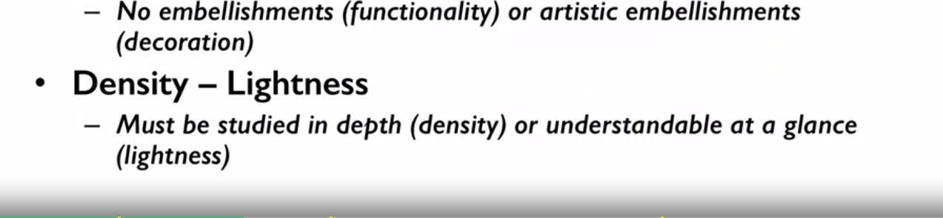
Here's an example from my field of study which was published by Harvard and MIT describing the patterns of access of users in the edX massive open online course platform.

Take a moment to study this image. What sense can you make of this image?

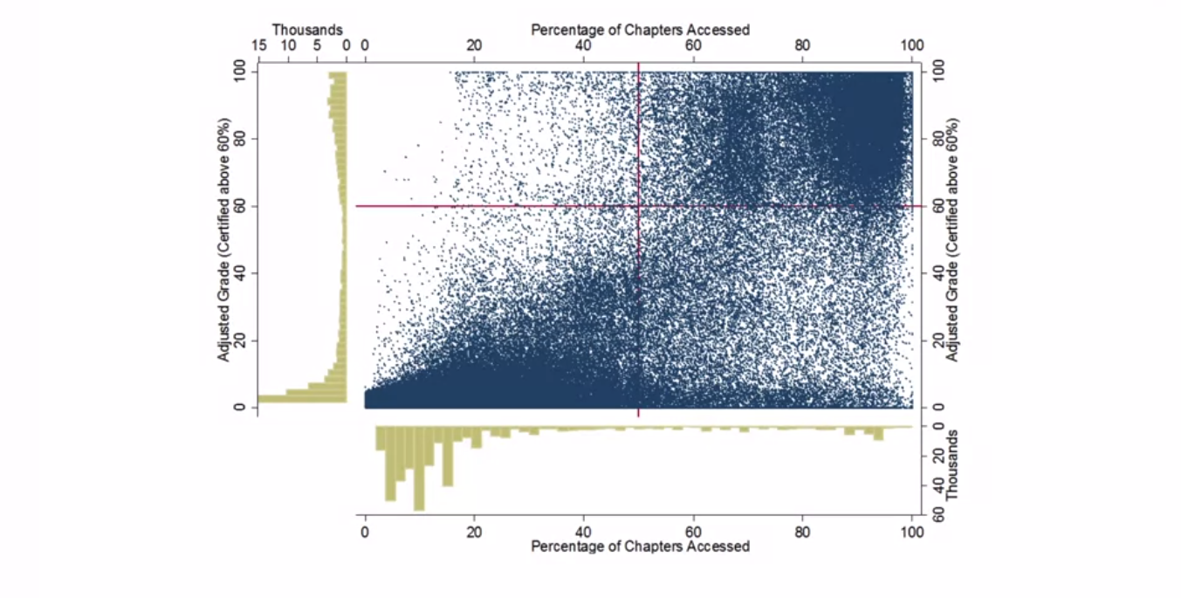
The axis for
the histograms can be a bit confusing as they bleed into the scatterplot axis, but
change the unit of measure and the direction of the measurement.
For instance, in the X axis at the top of the scatter plot,
percentage of chapters access is being used as the unit of measure and
increases as you move towards the right hand side of the figure.
You have the same X axis for the histogram to the left of the graph is in
thousands of persons and increases as you move to the left side of the figure.
There's some red lines overlayed on the graphic.
Breaking the scatter plot roughly into quadrants, but with minimal labeling it's
a little unclear what the quadrants end up representing.
Regardless of whether this is a good figure or
not, it would certainly be considered an example of a dense figure.

The fourth aspect Cairo maps is the dimensionality of the graphic.

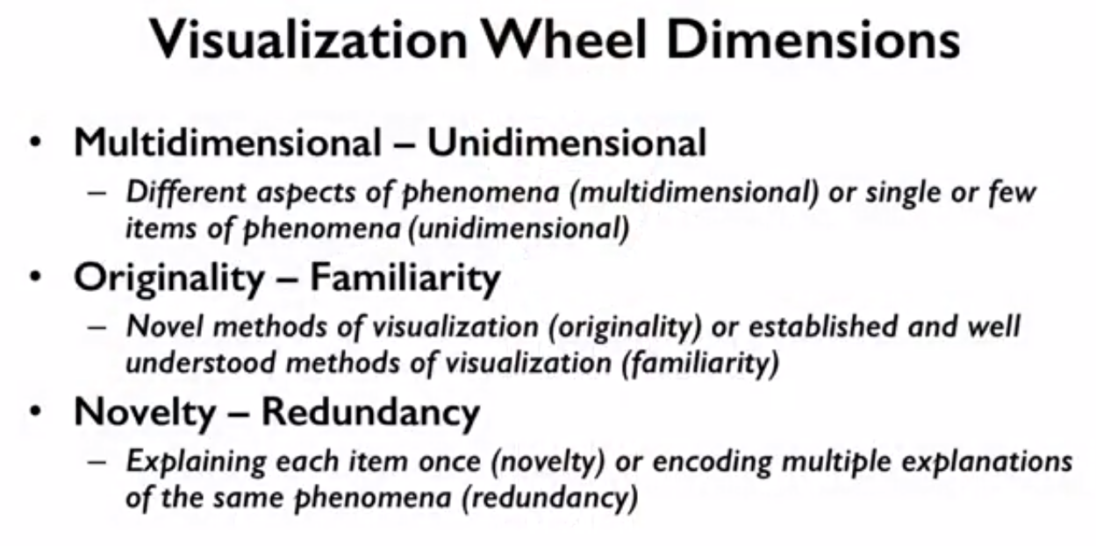

A multidimensional graphic describes a phenomena as a whole and
invites the viewer to explore many different aspects of the phenomena.
A unidimensional graphic instead focuses on a single or
a few items and explores them in one or more ways.
The fifth dimension is originality and familiarity.
In the modern world, we're used to seeing a plethora of different kinds of
information graphics, things like bar charts and line charts.
And thinking in terms of these representations is taught at a very
young age.
For instance, my daughter, who's almost five,
came home from preschool the other day with a page that showed a bar chart.
That she and others had made in class.
To celebrate learning about the American election, the whole class got together and
had a vote on what they would have for
snack, chocolate ice cream or mint chocolate chip ice cream.
Of course, mint chocolate chip ice cream won, as one might expect.
But, my point here, is that, these are basic ways of thinking about data in
a graphical form and they are now being taught very early on.
And this makes them familiar to a broad population.

This wasn't always so though.
It's safe to say that the bar chart is fairly familiar to most people but
a graphic with more originalities,
elements that need to be explained or studied by the user.
Here's a very famous graphic by Charles Minard.
It describes Napoleon's march into Russia in 1812.
Take a moment to study the graphic.
Broadly speaking, there are five different kinds of information being visualize in
this graphic.
How many of those five pieces do you see?
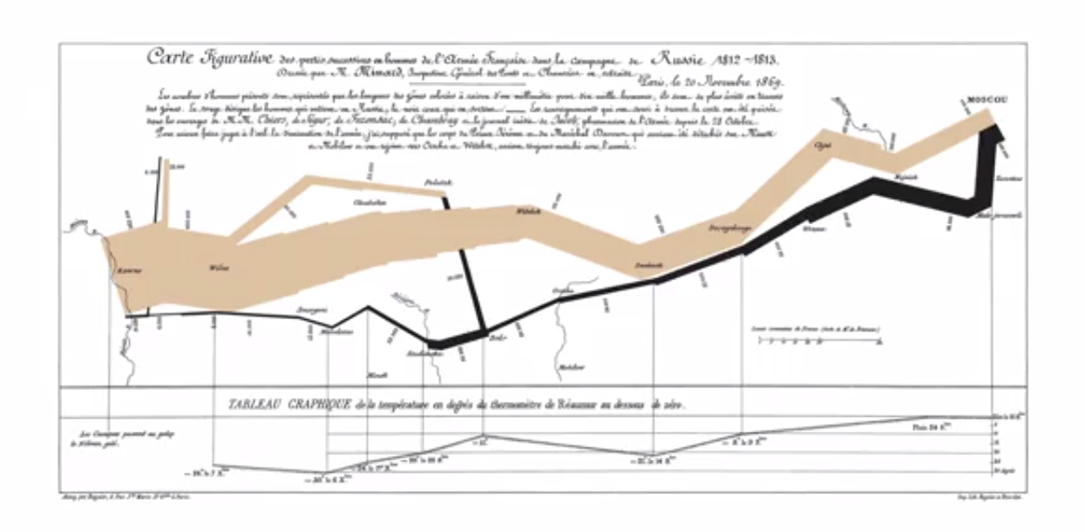

Here's what I see.
First there are elements of geography showing us the various
rivers in towns along the way.
The width of the tan upper bar represents the size of Napoleon's army, and
you can see it shrinks from the beginning of the campaign from 422,000 to
only 100,000 once the French reach Moscow.
The lower black bar shows Napoleon's retreat from Russia, and there are various
points along it which are mapped to dates and temperatures in Celsius.
We see the bar thins dramatically as the army shrinks in size.

So the five kinds of data in Minard's visualization include location,
direction, temperature, army size and dates.

The last dimension which Cairo shares is the novelty and redundancy dimension.
Redundancy is the tendency of a graphic to tell the same story in many
different ways.
For instance, you might use the height of bars on a bar chart with an axis as well
as color to emphasize the largest bar.
This one's a bit tricky, you don't want to bore your readers or
make your graphics overly complex.
But you do want to encode information in a way which supports their understanding of
the phenomena you've described.
On this dimension,
novelty is the act of describing each phenomena in the graphic in only one way.

There are no rights and wrongs in the visualization wheel.
The purpose of the wheel is to help you understand and
compare the visual approaches you might take.
As a reflective activity, Cairo suggested you can plot your thinking, a long each of
these dimensions and then join those points together, to create a radar plot.

Here Cairo provides two examples of the visualization wheel in action.
On the left hand side you see there is more emphasis towards complex visuals.
Those which are dense, multidimensional and have high functionality.
On the right, you see the visualization wheel.
There are more elements of decoration, lightness, and figuration.
Cairo suggests that the left wheel is more indicative of work
being done by scientists and engineers, while the right wheel is more
indicative of work being done by artists, graphic designers, and journalists.

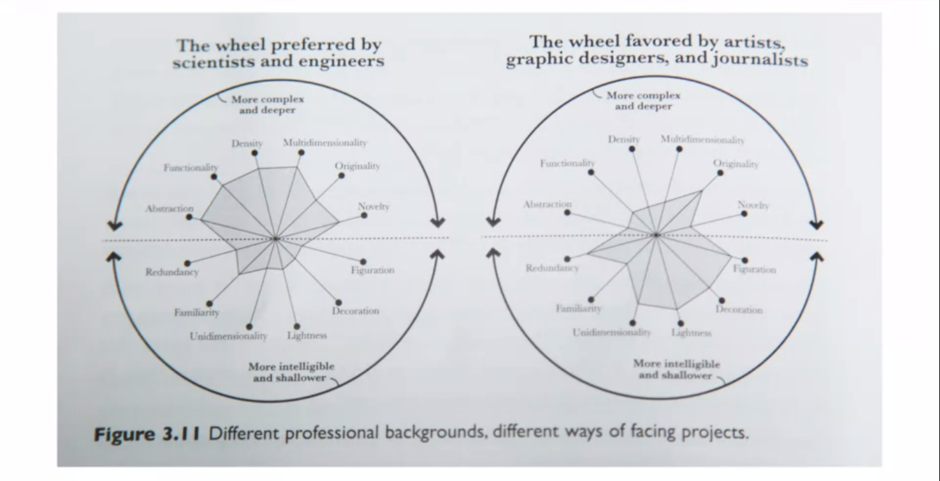
This tension between how scientists and engineers might view the visualization of
data, and how artists and journalists might, is an interesting one.
And we'll revisit it at the end of next week.
In the next lecture, we'll go a bit deeper, and consider some heuristics from
Edward Tufte, as to what makes a good visualization.

The visualization wheel is one tool which we have in order to better compare two
different ways of visualizing information.
In the next lecture, we'll dig in a bit and
see how you might use the visualization wheel to evaluate your own graphics.

